# R Exercises

1 .Create Waterfall chart that begins with a total from last year's sales and have some gains and some losses in sales, which are indicated by positive and negative values. The last row represents the current year's sales, which is the sum of all the rows:

DataSet: Waterfall.csv

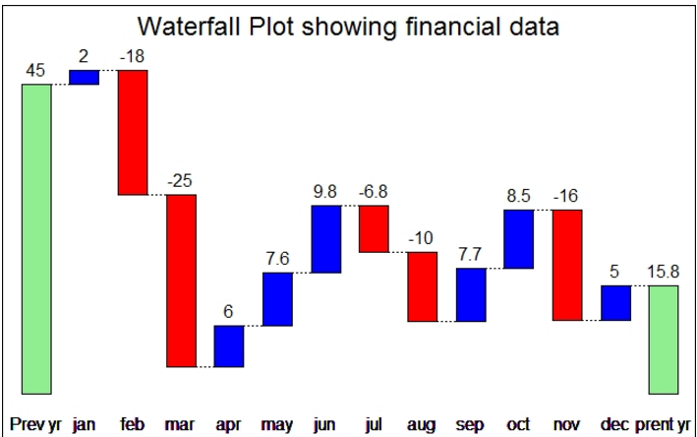

2. Use below data and create pie chart as shown in below figure.

data = c(179718,41370,41914,44280)

